Total Pet Plan Descriptions for Employee Facing Materials
Please send screenshots or files to marketing@petbenefits.com for approval.

From discounts on veterinary care and pet products to 24/7 pet telehealth and lost pet recovery service, Total Pet Plan from Pet Benefit Solutions helps you save on everything your pet needs. And best of all, it's less than 40 cents per day.

Enroll for one low rate today!

Total Pet Plan from Pet Benefit Solutions saves you money on everything your pet needs. There are no exclusions – even pets with pre-existing conditions are covered. Best of all, it's less than 40 cents a day!
Total Pet Plan includes:
- Up to 40% off and free shipping on prescriptions, preventatives, food, treats, toys, and more
- Same-day pickup for human-grade Rx from participating pharmacies
- Instant 25% savings on in-house medical services at participating veterinarians
- 24/7 pet telehealth with US-based licensed veterinarians
- A durable ID tag and lost pet recovery service
Enroll for one low rate today!

Total Pet Plan from Pet Benefit Solutions is a pet care bundle helping you save on everything your pet needs for less than 40 cents a day. There are no exclusions – even pets with pre-existing conditions are covered.
Combining the best in pet care, Total Pet Plan members get access to:

- Up to 40% off and free shipping on all orders from PetCareRx.com, including medications, food, toys, treats, and more
- Same-day pickup for human-grade prescriptions at participating pharmacies such as CVS, Walmart, and other CVS Caremark® pharmacies
- Instant 25% savings on all in-house medical services at participating veterinarians; easy-to-use with no claim forms or deductibles
- 24/7 access to licensed US-based veterinarians for questions regarding your pet's health and behavior
- Durable ID tag and 24-hour lost pet recovery helpline to protect your pet if they go missing

Enroll for one low rate today!

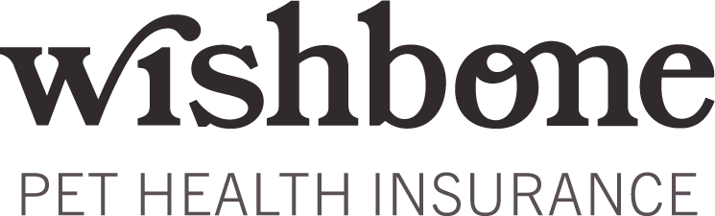

Wishbone Plan Descriptions for Employee Facing Materials
Wishbone disclosure provided to include below any of the plan descriptions if you choose to.
Please send screenshots or files to marketing@petbenefits.com for approval.

Give your best friend their best life with Wishbone Pet Health Insurance!
With 90% reimbursement on accidents and illnesses, a low $250 annual deductible, and two optional routine care add-ons, you can have maximum coverage! Lost pet recovery and 24/7 pet telehealth services are included for each insured pet.

Fetch a quote today!

Give your best friend their best life with Wishbone Pet Health Insurance!
Wishbone offers high-value, easy-to-use pet health insurance at exclusive employee benefit rates.

With Wishbone, you get:
- 90% reimbursement on accidents and illnesses
- A low $250 annual deductible
- Fast claims processing
- Visit any licensed veterinarian
- Easy-to-use member account
- And so much more!

Plus, choose one of two optional routine care add-ons to maximize your savings on pet care. All Wishbone policies include 24/7 pet telehealth and a durable pet ID tag with a lost pet recovery service.

Fetch a quote today!

Give your best friend their best life with Wishbone Pet Health Insurance!
Wishbone offers high-value, easy-to-use pet health insurance at exclusive employee benefit rates. Get reimbursed for vet bills that resulted from an accident or illness with your pet.

Coverage includes diagnostics and testing, unexpected surgery, hospitalization, emergency care, hereditary and congenital conditions, and more.

With Wishbone, you get:
- 90% reimbursement on accidents and illnesses
- A low $250 annual deductible
- Fast claims processing
- Visit any licensed veterinarian
- Easy-to-use member account
- And so much more!

Plus, choose from two tiers of optional routine care add-ons to maximize your savings on everyday pet care.

Submit a claim from your account online. Claims are processed within five business days, and you'll receive fast reimbursement payouts via check or direct deposit. Wishbone includes a durable ID tag with lost pet recovery service and 24/7 pet telehealth support for each insured pet.

Fetch a quote today!

Wishbone Disclosure:
Wishbone Pet Insurance is a program managed by Odie Pet Insurance Marketing, Inc. and underwritten by Clear Blue Insurance Group. Please visit www.getodie.com for more information. Policies do not cover pre-existing conditions. Waiting periods, annual deductible, co-insurance, benefit limits and exclusions may apply. For full terms, visit Terms and Conditions. Products, discounts, and rates may vary and are subject to change.

